Inventory with Count Use

Utilizing Count Use to inventory a collection is much more user friendly than the default inventory method, which is quite an intense and lengthy process. This procedure allows staff to easily indicate whether an item was found or not found.
Functions and Tools Needed
- Sierra Desktop App
- Count Use function and permissions
- Create Lists function and permissions
- Laptop
- Barcode Scanner
Next Steps
Verify whether or not you have counts (numerical data) in the internal or copy use fields of your collection.
- If so, check whether one of the fields is consistently free.
- If both are in use, one of the fields will need to be cleared in all item records. Submit a ticket to Maine InfoNet to clear the field you are going to use in the item records.
- Once you have determined the above and have cleared a field for inventory use, you can move on to the Inventory Process.
Inventory Process
To begin inventorying the collection, it is very simple to do…
Count Use
- Open Sierra and navigate to the Count Use function you are using to inventory.
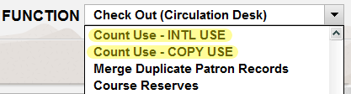
- Begin scanning the barcodes of items found on the shelf. The count use field will update by one increment.

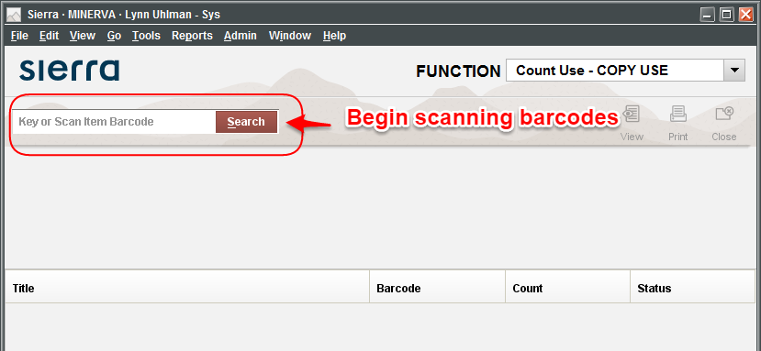
Create Lists
Next, you’ll want to create some review files so you can identify which items were found and which weren’t.
Inventory Found
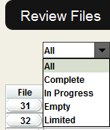
Create a review file to find your inventoried items.
- Go to the Create Lists function.
- Find an empty review file by selecting the drop down menu arrow and choose Empty.
- Double-click on an empty review file that has a Max Records capacity to suit your needs.
- The Boolean Search screen should appear.
- Enter in a Review File Name.
- Change the Store Record Type to Item i.
- Leave the Range set to the default Start and Stop item record numbers.
- In line 1 of the parameters:
(Double click the parameter boxes to see the available options.)
  - Type to Item - i
  - Field to LOCATION - 79
  - Condition to Starts with - ^
  - Value A to (your library’s 3 digit code)
- Click the Append Line button.
- In line 2 of the parameters:
  - Type to Item - i
  - Field to COPY USE - 94 - or - INTERNAL USE - 93
  - Condition to greater than or equal to - >=
  - Value A to 1
- Once your screen looks like the above, click on the Search button.
- Next, change the Review File view to All or Limited.
- Find your review file and check the Status column. If it is complete, you can now work with the list.
Inventory Not Found
Next, create a review file that finds all the items not inventoried.
- Go to the Create Lists function.
- Find an empty review file by selecting the drop-down menu arrow and choose Empty.
- Double-click on an empty review file that has a Max Records capacity to suit your needs.
- The Boolean Search screen should appear.
- Enter in a Review File Name.
- Change the Store Record Type to Item i.
- Leave the Range set to the default Start and Stop item record numbers.
- In line 1 of the parameters:
(Double click the parameter boxes to see the available options.)
  - Type to Item - i
  - Field to LOCATION - 79
  - Condition to Starts with - ^
  - Value A to (your library’s 3 digit code)
- Click the Append Line button.
- In line 2 of the parameters:
  - Type to Item - i
  - Field to COPY USE - 94 - or - INTERNAL USE - 93
  - Condition to Equal to - =
  - Value A to 0
- Once your screen looks like the above, click on the Search button.
- Next, change the Review File view to All or Limited.
- Find your review file and check the Status column. If it is complete, you can now work with the list.
Post-Inventory Process
Develop a Workflow
The key purpose behind developing a workflow is to identifying the inventory status on records and to process checked out items as they come back in. What works best for your library, may not work for another, so keep in mind that the following are suggestions to help account for things currently on your shelves, checked out, or missing.
The best method to identify items that weren’t inventoried is to update the status to missing and add an item note field to the record. This will help you in the future when assessing repurchase or to create a list to delete the record from the database.
Those items that are checked out during the inventory process will need to be accounted for, as well. You can process them through Count Use as they are checked back in, you can give them to a staff member to process before shelving or you can do a second inventory. Figuring out the best workflow at this point is up to you, but below are a few suggestions for notes to help you out.

Suggestions
Account for the inventory process on the item records in some way, such as adding a note, a message or changing the status to missing. The exact wording is up to you, but simple and consistent is the best method.
NOTE: Remember to include the marc tag 901 in your note fields, so that the inventory information can be separated from other notes on the record if batch updating/processing is needed.
Examples
Item found on the shelf:
Add a note to the item record indicating that the item was inventoried and the date it was processed.
x 901 Inventoried 03-02-2016
Item not found on the shelf:
Change the status message to Missing and add a note field to the item record.
x 901 Not found during Inventory. 03-02-2016
Item checked out at the time of inventory:
Add a message to the item to indicate that it needs to be inventoried when it is returned. Again, the wording and workflow is up to you, so it can indicate that it needs to go to a particular staff member or that someone at the circ desk needs to inventory it through the Count Use function. You may even choose to skip this step and develop another method that works best for your library. Whatever the method, remember to keep the message consistent.
m Please scan item through Count Use -- Copy Use for inventory purposes. 03-02-2016
Submit a ticket
Once you have your lists together and the workflow and format of your notes/messages solidified, submit a ticket to Maine InfoNet to have the records batch updated.
- Go to http://support.maineinfonet.org.
- Login to Support Center in order to submit a ticket.
- When filling out the ticket, please provide the following information:
  - Create Lists review file #.
  - Name of review file.
  - Indicate that you want to add a note or message field.
  - Indicate if the status should be updated to Missing for non-inventoried items
  - Exact verbiage of note/message.
  - Also, mention any other batch steps that you would like done to the list.
In the not so distant future…
Decide upon a time when you will review the non-inventoried collection. You may decide to check the shelves again for those specific items before deleting them from the system.
Depending on the workflow chosen, you may ascertain that they can be deleted without another search. The point being that its now time for the non-inventoried records to be removed from the system.
Create another list
- Go to Create Lists function.
- Find an empty review file by selecting the drop down menu arrow and choose Empty.
- Double-click on an empty review file that has a Max Records capacity to suit your needs.
- The Boolean Search screen should appear.
- Enter in a Review File Name.
- Change the Store Record Type to Item i.
- Leave the Range set to the default Start and Stop item record numbers.
- In line 1 of the parameters:
(Double click the parameter boxes to see the available options.)
  - Type to Item - i
  - Field to LOCATION - 79
  - Condition to Starts with - ^
  - Value A to (your library’s 3 digit code)
- Click the Append Line button.
- In line 2 of the parameters:
  - Type to Item - i
  - Field to STATUS - 88
  - Condition to equal to - =
  - Value A to m
- Click the Append Line button.
- In line 3 of the parameters:
  - Type to Item - i
  - Field to Marc Tag - !
  - Enter 901 in the pop-up box.
  - Click OK
  - Condition to has - H
  - Value A to (the wording you chose to add to your note fields)
- Once your screen looks like the above, click on the Search button.
- Next, change the Review File view to All or Limited.
- Find your review file and check the Status column. If it is complete, you can now work with the list.
Submit a ticket
Once you have your lists together and the format of your notes/messages solidified, submit a ticket to Maine InfoNet for the records to be deleted.
- Go to http://support.maineinfonet.org.
- Login to Support Center in order to submit a ticket.
- When filling out the ticket, please provide the following information:
  - Create Lists review file #.
  - Name of review file.
  - Identify that the records are to be deleted.
  - Mention whether or not checked out items are to be deleted -- if not let us know what you would like done with them.
NOTE: Clearly, this would only be for items that were checked out prior to or during the inventory process that haven’t returned. However, if you have concerns that non-inventoried items might have been checked out since then, append your list above to not include anything checked out after a certain date.

