ILL Statistics without a Juv. Scope

Measuring Outgoing & Incoming Inter-Library Loan

Go to http://minerva.maine.edu/manage
- Click Circ Activity
- Enter initials and password you usually use in Minerva
- Click Owning/Home
- Click Submit
- At the next screen:
  - Leave TOTAL selected,
  - Do NOT check the “Include statistics…” box,
  - Select your time frame.
- Click Submit Query
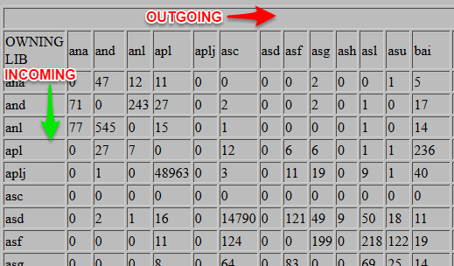
- Wait 30 seconds or so at the “The statistical report is calculating…” page. Then Click STATUS. (If it does not load the table, then wait another 30 and try again.)
At this point, it’s much easier to look at this table if you select all of it, copy it, and paste it into Excel.
- Find your library in the left-most column, then follow the row across to the totals column at the far right. Enter this number in the A cell of the Formulas table below.
- Find your library in the top row, then follow the column down to the very bottom. Enter this number in the B cell of the Formulas table below.
If you are curious about what is from MaineCat, look at the numbers just before the totals, coming from “Blank” Those are MaineCat transactions (incoming and outgoing)
Formulas
A | OUTGOING
B | INCOMING

