Create Lists Training

The following directions have been extracted from the Create Lists manual for the purpose of training. For a more concise and regularly updated information on Create Lists, please find the manual at http://www.maineinfonet.org/supportportal/training/create-lists/.
Creating a Review File Off of another Review File
- Select an empty review file.
- Click the Search Records button.
- The Boolean Search window will appear.
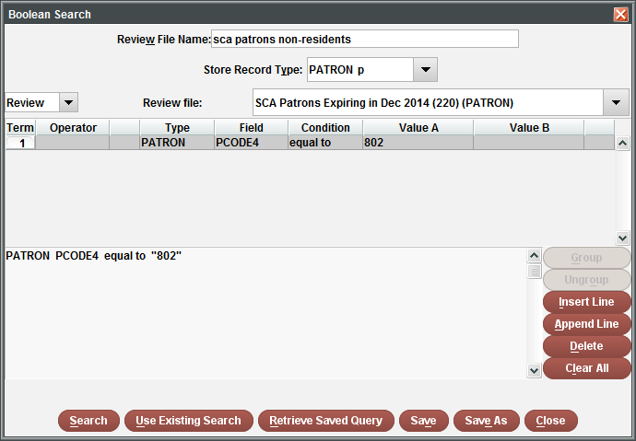
- Name the Review File.
- Select the Store Record Type. Remember this is dependent on the record links (refer to Record Links), so the file you wish to create a review on has to be either the exact record type or a linked record type.
- Change the Range to Review.
- In the Review file drop-down menu, scroll until you find the review file you want to create a list off of.
- Enter the search parameters.
- When ready, click the Search button to run the list.

Use Existing Search
- Select an empty review file.
- Click the Search Records button.
- The Boolean Search window will appear.
- Name the Review File.
- Click the Use Existing Search button.
- Scroll through the search list and select the list to be used.
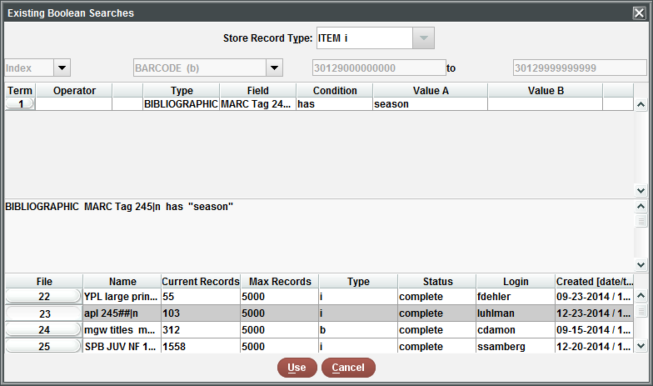
- Click the Use button.
- When ready, click the Search button to run the list.

Retrieve Saved Query
- Select an empty review file.
- Click the Search Records button.
- The Boolean Search window will appear.
- Name the Review File.
- Click the Retrieve Saved Query button.
- Scroll through the search list and select the list to be used.
- Click the Select button.
- When ready, click the Search button to run the list.
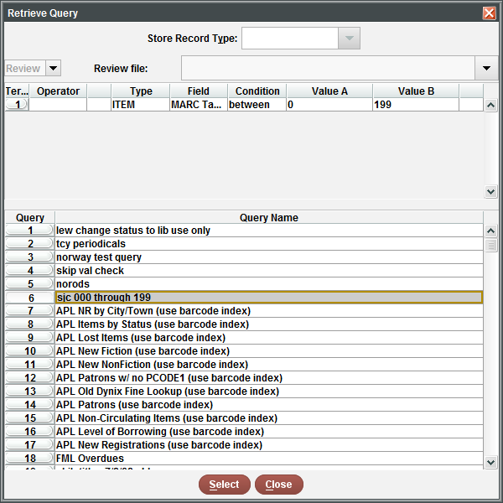

Export Records
The Export Records button allows the user to export a review files select data in .txt format. This enables the user to bring the data into another program and manipulate the data for some other purpose, i.e. a spreadsheet or report.
- Select the Review File to be exported.
- Click the Export Records button.
- Enter the fields that you would like exported. Use Append to add lines to the end of the list and use Insert to add a line in between parameters.
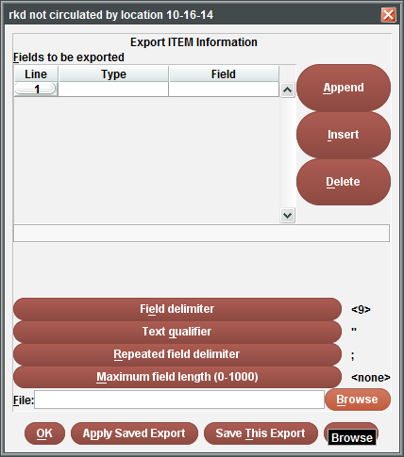
- Select the Field delimiter button.
- Click the radio button next to Control character (1-127). Enter 9 in the text box.

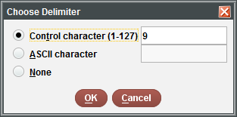
- Click OK.
- Select the Browse button.
- Enter a name and Save the file in an easy to find location.
- Once done, your Export parameters should look similar to this:
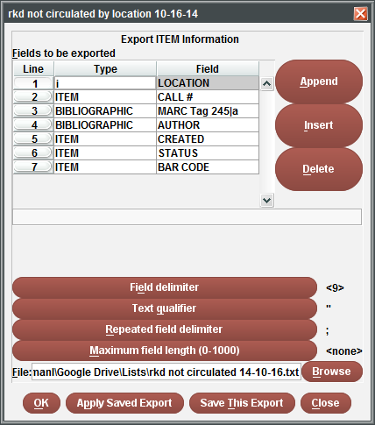
- If everything looks good, click OK.

Manipulating an exported list
An exported list can be manipulated in other programs that support the exported file type. Our system uses *.txt or a text file to export data. Depending on how the list was exported it may be comma separated or use other delimiters to separate the data. The delimiters assist the program in parsing the data into the appropriate fields to make it legible. To manipulate your list into a view-friendly list, report, etc., refer to the following:
- Open Excel.
- Select Open.
- Browse for the exported review file and open it.
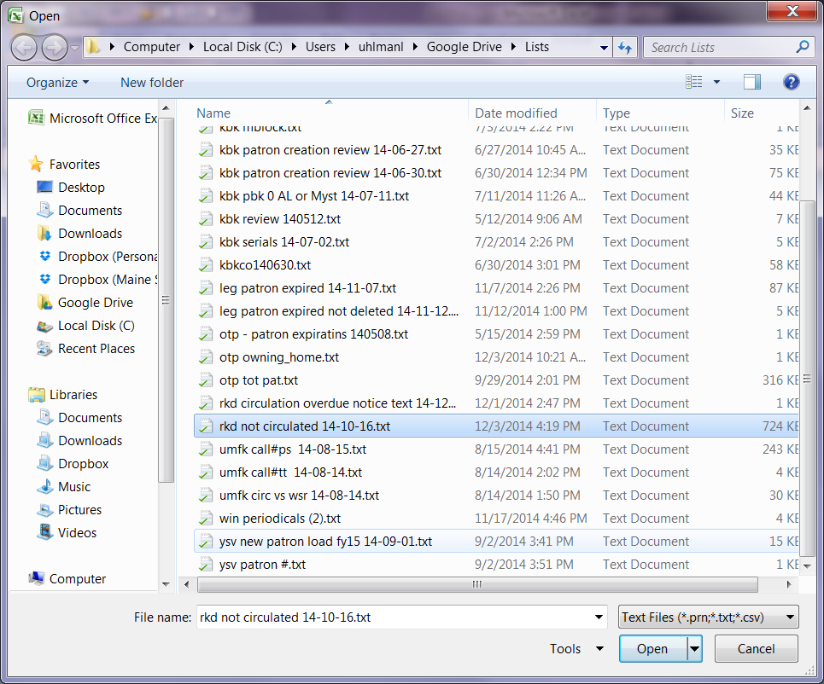
- If you receive this message, select Yes. Otherwise, move on to #5.
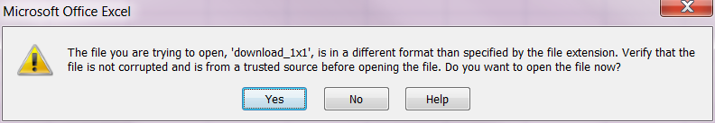

- In the Text Import Wizard, make sure the Delimited radio button is selected and click Next.
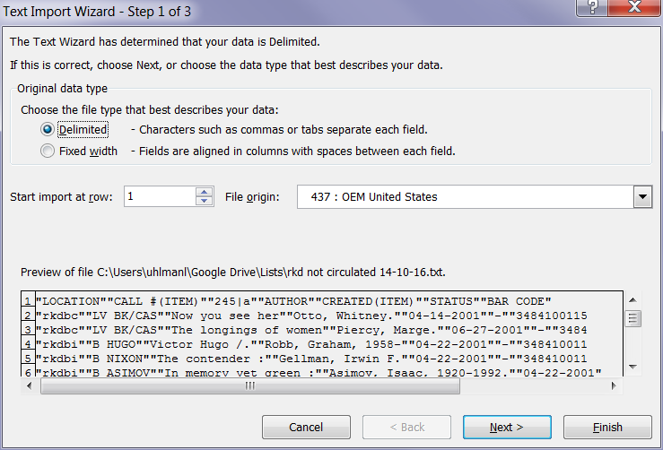
- Click the checkbox next to Other and insert the character |(pipe).
- Click Finish.
- The list should now be in an easily viewed format and editable.
- Adjust the cell format and width as necessary.

List Examples
Location Count
- Go to Create Lists.
- Find an empty review file by selecting the drop down menu arrow and choose Empty.
- Double-click on an empty review file that has a Max Records capacity to suit your needs.
- The Boolean Search screen should appear.
- Enter in a Review File Name.
- Change the Store Record Type to Item i.
- In the drop-down menus, change the first one to Index and the second to Barcode. Next, enter your beginning barcode range 3xxxx000000000 and your ending barcode range 3xxxx999999999 in the text boxes.
Example:
- Leave the parameters blank.
- Once your screen looks like the above, click on the Search button.
- Next, change the Review File view to All or Limited.
- Find your review file and check the Status column. If it is complete, you can now work with the list.

Not Circulating
- Go to Create Lists.
- Find an empty review file by selecting the drop down menu arrow and choose Empty.
- Double-click on an empty review file that has a Max Records capacity to suit your needs.
- The Boolean Search screen should appear.
- Enter in a Review File Name.
- Change the Store Record Type to Item i.
- In the drop-down menus, change the first one to Index and the second to Barcode. Next, enter your beginning barcode range 3xxxx000000000 and your ending barcode range 3xxxx999999999 in the text boxes.
Example:
- In line 1 of the parameters:
(Double click the parameter boxes to see the available options.)
- Type to Item - i
- Field to TOT CHKOUT - 76
- Condition to Equal to - =
- Value A to 0
- Click the Append Line button.
- In line 2 of the parameters:
- Type to Item - i
- Field to CREATED - 83
- Condition to less than or equal to - <=
- Value A to mmddyy (If you don’t want anything more recent than January 1, 2013 then enter 12-31-2012)
- Once your screen looks like the above, click on the Search button.
- Next, change the Review File view to All or Limited.
- Find your review file and check the Status column. If it is complete, you can now work with the list.

Items on patron accounts that should have received an Overdue notice
- Go to Create Lists.
- Find an empty review file by selecting the drop down menu arrow and choose Empty.
- Double-click on an empty review file that has a Max Records capacity to suit your needs.
- The Boolean Search screen should appear.
- Enter in a Review File Name.
- Change the Store Record Type to Item i.
- In the drop-down menus, change the first one to Index and the second to Barcode. Next, enter your beginning barcode range 3xxxx000000000 and your ending barcode range 3xxxx999999999 in the text boxes.
Example:
- In line 1 of the parameters:
(Double click the parameter boxes to see the available options.)
- Type to Item - i
- Field to ODUE DATE – 73 or whichever PCode you use to classify your non-resident patrons.
- Condition to equal to - =
- Value A to today’s date
- In line 2 of the parameters:
(Double click the parameter boxes to see the available options.)
- Type to Item - i
- Field to # OVERDUE – 72 or whichever PCode you use to classify your non-resident patrons.
- Condition to greater than or equal to - >=
- Value A to 1
- In line 3 of the parameters:
(Double click the parameter boxes to see the available options.)
- Type to Item - i
- Field to STATUS – 88 or whichever PCode you use to classify your non-resident patrons.
- Condition to not equal to - !=
- Value A to n
- Once your screen looks similar to the above, click on the Search button.
- Next, change the Review File view to All or Limited.
Find your review file and check the Status column. If it is complete, you can now work with the list.

Patrons who should have received bills
- Go to Create Lists.
- Find an empty review file by selecting the drop down menu arrow and choose Empty.
- Double-click on an empty review file that has a Max Records capacity to suit your needs.
- The Boolean Search screen should appear.
- Enter in a Review File Name.
- Change the Store Record Type to Patron p.
- In the drop-down menus, change the first one to Index and the second to Barcode. Next, enter your beginning barcode range 2xxxx000000000 and your ending barcode range 2xxxx999999999 in the text boxes.
Example:

- In line 1 of the parameters:
(Double click the parameter boxes to see the available options.)
- Type to Item - i
- Field to ODUE DATE – 73 or whichever PCode you use to classify your non-resident patrons.
- Condition to equal to - = (alternatively, if you are looking for the time period equal to and prior to today, choose less than & equal to <=).
- Value A to today’s date
- Once your screen looks similar to the above, click on the Search button.

- Next, change the Review File view to All or Limited.
- Find your review file and check the Status column. If it is complete, you can now work with the list.
- Change the Function to Notices
- Create a Notices job for Statement of Charges.
- Under Options, make sure to set the drop-down menus to:
- Review in the first drop-down.
- Select your review file name in the second drop-down menu.
- If you don’t want charges or fees from other dates to appear on the statement, change the Charges Incurred After date to the previous day.
- Your screen should look similar to the following:
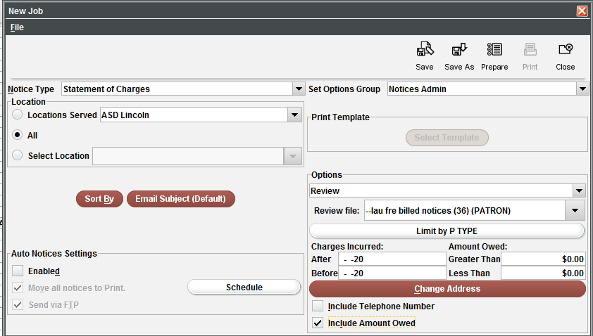

- Select Prepare.
- The bottom half of the screen should look similar to below:
- Click Send Notices. ** You can send the print notices to the local printer or select the email notices to go to the patron’s email --OR-- you can switch the view to the email notices and select the Move All to Print Queue button. This allows you to print all notices to the local printer.
- Once they have been sent, the following pop-up will appear:
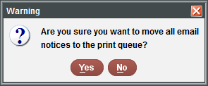
- Select Yes or No. This really doesn’t matter in this instance since the data was grabbed from a system table, but from the review file you created.
- The printouts should look similar to the following:
