Checkouts & Renewals
Home Library
Web Management Reports
- Go to:
- Minerva -- http://minerva.maine.edu/manage
- URSUS -- http://ursus.maine.edu/manage
- MILS -- http://mils.maine.edu/manage
Checkouts
- Pick Circ Activity
- Login with your username and password
- Pick the following:
  - CIRC STATS: Checkout
  - DATES: whatever timeframe you’re after
  - LOCATIONS: System
  - TYPE: Home Libr
- Click Submit
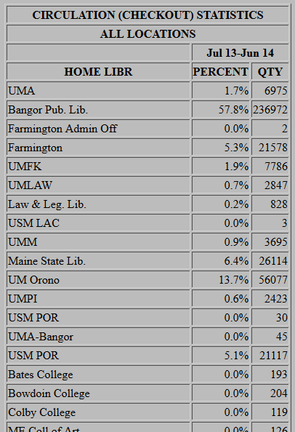
- If you chose User Spec for the date you will be prompted to select a date range. Click Submit Query once you have chosen your date range.
- Find your library’s name in the list and record the number of checkouts next to it.
Renewals
- Pick Circ Activity
- Login with your username and password
- Pick the following:
  - CIRC STATS: Renewal
  - DATES: whatever timeframe you’re after
  - LOCATIONS: System
  - TYPE: Home Libr
- Click Submit
- If you chose User Spec for the date you will be prompted to select a date range. Click Submit Query once you have chosen your date range.
- Find your library’s name in the list and record the number of checkouts next to it.
Item Location
Checkouts
- Pick Circ Activity
- Login with your username and password
- Pick the following:
  - CIRC STATS: Checkout
  - DATES: whatever timeframe you’re after
  - LOCATIONS: System
  - TYPE: Location
- Click Submit
Find your library’s name in the list and record the number of checkouts next to it.—it may be listed twice because of some MaineCat transactions listing differently. I’m trying to get rid of that, but it’s worth checking. If it’s there twice, just add them together.
Renewals
- Pick Circ Activity
- Login with your username and password
- Pick the following
  - CIRC STATS: Renewal
  - DATES: whatever timeframe you’re after
  - LOCATIONS: System
  - TYPE: Location
- Click Submit
Find your library’s name in the list and record the number of checkouts next to it.

