University of Maine System and URSUS
Library Directors’ Council
Held at Bangor Public Library
Friday, March 9, 2007
Meeting Notes w/ URSUS report and Tim’s report
Attending: Brian Damien (PPL), Tom Abbott, Joyce Rumery, Sharon Johnson, Greg Curtis, David Nutty, Jonathan Williams, Frank Roberts, Bert Phipps, Barbara McDade, Karl Beiser, Chris Knott and Susan Lowe
1. No additional changes on the meeting notes from December meeting
2. Report on Emerging Libraries conference attended by Barbara and Karl – Barbara will provide highlights for all. A few points of interest from her presentation
• The way students are learning is changing
1. More collaborative
2. Traditional libraries are less important to them
3. Libraries role changes to creating portals to information – librarians role is to find information, compile it, build portals, content access management and avatars to support access – and helping the amateur searcher get “unstuck” when he or she reaches that point
• People learn best by tinkering
1. Chemistry lab online
2. Engineering modeling in 3D
3. See e-book example attached “Age of Dinosaurs”
• From the British Library
1. Market well
2. Streamline functions and services
3. Develop people
4. Invest in Innovation\
• Need ability to compare things – internet access and common long term storage for data and archives with distributed access – managing these resources will be another function for Librarians and Information professionals, e.g., 95% of what is useful in medicine and law are online – the same will be true of other professions as they catch up
• National Science Foundation is discussing possible grant funding for several startup data archives with major funding support. UMS will be asked to consider submitting a grant application – Karl will prepare a briefing paper and Chief Academic Officers on each campus (and others?) have already been contacted and asked to identify individuals who should be involved. Recommendation from Tom: Librarians need to be front and center on this project. (On Next Agenda)
3. Legislative update: Joyce and Barbara provided information on LD 793/SP 242, An Act to Provide Essential Library Resources to all Maine Communities – and will keep us informed about how best to support its passage. Other bills for databases and cultural centers are also pending.
4. LibQUAL: A few notes from each campus’ experience thus far:
• USM – in 5 days 825 responses – set goal of 1000 in the first seven days – verified what we were told about the critical nature of marketing and reminder notes
• UMFK – first week 320 total (130 ug, 17 fac, 39% of staff) with 88 comments
• UMPI – very slow response thus far – however a reminder notice and recruitment of faculty to promote the survey in class has helped raise the number of responses
• OCLS – Susan reported that she has had 201 responses with overlapping comments about campus libraries which she will share with that campus
• UMM – 110 out of 600 students and 7 faculty
• Notes: check out USM, and UMFK’s websites for how they used the LibQUAL graphics and announced the survey - at USM the announcement popped up in all the computer labs and on the library computers (David Eldridge of IT helped with that – all libraries have agreed to share ideas and graphics for this project – )
5. Reference Meeting At PPL on March 21 (On Next Agenda)
6. Serials Collection analysis with EBSCO is progressing – Deb Rollins will provide an update when it is available (On Next Agenda)
7. Security on III software: there is concern that student social security numbers are available to student workers and will continue to be accessible even after all student ID numbers are converted to random alpha numeric codes –Jonathan is investigating a method for blocking viewing access unless you have a staff PW (On Next Agenda
8. Blackboard Library Tab – All agreed to replace the temporary page now in place with the MARINER Main page – Susan is going to replace the current page with the Mariner page.
9. For next agenda: Greg/Karl/Joyce please report on any progress on the possibility of using a building at BNAS as a last storage center – and draft strategy steps for our consideration – thank you
10. Maine Info Net: David reported results of organizational discussions. The MINERVA board has taken steps to formalize its role and functions. David asked the URSUS libraries to consider the Maine Info Net decision-making process to include opportunities for the MINERVA Board to make policy decisions and have them considered by the Maine Info Net Board in way similar to how URSUS libraries operate now. No one at the URSUS meeting objected but did raise the question about whether the process would accommodate taking policy decisions from the MI Board back to the MINERVA Board for review and consideration – the assumption is that this would also be part of the representative process. – David and Karl will pursue and report back to us.
11. Scoping III: it costs $2000 for III to do scoping work for the URSUS libraries. Some new scoping will occur to support YA collections for the publics in June. We are all asked to let Jonathan know if we need additional categories scoped, e.g., UMA should have Holocaust-Human Rights added. However, please check the long list of existing categories already available before making the request to Jonathan.
12. Diversity Project: David shared the “Diversity at USM Project Proposal” with everyone with the request that we all support something similar at our campuses. The goal is to create a website for each campus that organizes information on diversity resources at that campus – See USM Proposal attached
13. Library Assistant III update: much of the work of identifying the functions of this new clerical position has been completed. There remains a question however about finding the unique “space” for this work between the existing LA IIs and the entry level professional, Library Associate. Tom suggested that the position be called a “Library Specialist” or something similar with generic responsibilities, with the requisite higher level and independent functioning. This would help create the position without stepping on existing toes, and also allow each library to create its own specialized function(s) for the position. The group agreed to consider this approach. David, Joyce, and Frank were asked to reframe the LA III position in light of this new concept – and include as possible “specialties” the categories of higher level functions that Susan accumulated and organized.
14. URSUS report: See Jonathan’s report at end of these notes – some highlights:
• URSUS migration to new server went exceptionally well and speed has increased in numerous areas – please report improvements to Jonathan
• Code4 Lib Conference – Jonathan and Tim attended the conference in Georgia – focused on creation of software in libraries
• PPL: timeline for PPL’s migration to URSUS in nearing completion
• Espresso – Jonathan continues to improve the search engine
• Patron Authentication for licensed databases – some hacking problems being addressed – See Tim’s report for details – at end of these notes.
15. Karl’s additional comments:
• Delivery Service having some problems – seem to be with centralized sorting – please report to Joyce whenever they happen
• Re-launching MaineCat for what used to be SOLAR libraries
• In response to a question about Google Scholar, Karl indicated Jonathan could help any campus library profile Google Scholar search button for their library webpages - similar to what is on MINERVA – it works with your campus’ IP range
16. Other:
• Bert asked about Appropriate Behavior policies – several directors agreed to send copies of their policy to all URSUS libraries –
• For next meeting – review of UMS Strategic Direction #4 for progress report to the System and to help chart our agenda for the rest of this year.
• Summer retreat meeting in Farmington – Frank has proposed the week ending with Summer Fest in Farmington which is held on Saturday July 28th – possible schedule: Arrive afternoon of Thursday the 26th, dinner together that evening, Meetings all day Friday the 27th, with the option to stay for the Summer Fest activities on Saturday – please be prepared to make a decision on this proposal at next meeting – thank you Frank
THIS YEAR’S MEETING SCHEDULE:
All at Bangor Public Library – scheduled as follows:
April 13
May 25
LIBRARY DIRECTORS’ ITEMS FOR THE YEAR – this is the beginning of the year’s agenda – feel free to edit as needed
• Fine policy for future
• LibQual – ongoing
• Decision on continuing Docutek
• Career ladder system for MLS librarians – system-wide
• Library Assistants III for support staff
• Cooperative collection development consistent with goals of UMS Strategic Plan
• Analyzing “avoidable” collection duplication
• library buying items to be shared instead of each purchasing them, and/or,
• sharing campus library purchase funds to purchase shared central database or single item to be shared
• Last copy center if possible and if not – planned sharing via cooperative collection development
• Digitizing bound publications where we control copyright
~~~~~~~~~~~~~~~~~~~~~~~~~~~
URSUS Directors’ Report
March 9, 2007
- URSUS Migration: The URSUS migration from the Alpha server to the new Dell 2950 server running Linux took place on the morning of March 6. The server was brought online just after noon, and it appears to be working quite well. I have received a few reports of incorrect due dates since the migration, but I believe we have resolved the problem that caused these, and I have not had any new reports of this issue since March 6. The server itself is considerably faster than the old one, and it is also on a faster network. I have noticed considerable improvements in the performance of certain tasks, and I have heard reports from several libraries that the system seems to respond more quickly than it did before.
- Code4Lib Conference: Tim Pellett and I had the opportunity to attend the second Code4Lib Conference in Athens, Georgia, from February 28 to March 2. Code4Lib is a unique conference focused around the creation of software in libraries. We had the opportunity to meet a number of people who are creating very interesting software projects in their own libraries. The kinds of projects discussed included everything from open source ILS products, to metasearch applications, to advanced spell check features for search engine applications. The level of energy at this conference was very high, and we came away with a renewed enthusiasm for developing new applications in today’s library environment.
- Portland Public Library: Sarah Campbell and I put together a timeline for the migration to URSUS which will see their data loaded in early June. We will be meeting with Joyce Rumery, Steve Podgajny and Gary Nichols near the end of March to work out the technical details of the transition. We will also set up some training sessions with the staff at the PPL in order to prepare for the migration.
- Espresso: The backend for the Espresso search engine is more or less complete for the pilot project. I will continue to do work on this part of the application, but our focus for the next few weeks will be the user interface for the application. Tim Pellett and I will be working together on this part of the project. We will be moving this project to a new server soon, which should improve the indexing performance of the application.
- Patron Authentication for licensed resources: Please see report from Tim Pellett that follows.

UMS Libraries Authentication Systems Modifications
Tim Pellett
March 6, 2007

Two security breaches occurred recently which impacted access to licensed resources: .

1. Excessive usage by an on campus user resulted in a journal vendor, ACM, restricting future usage until the problem was resolved.
2. A patron barcode was being distributed around the internet allowing fraudulent access to our resources.
To address these events we implemented several modifications to the authentication systems
- Ticket authentication has been set up for the Orono proxy server. This provides each user with a unique digital signature that is time stamped and linked to either an IP address for on campus users or patron barcode for remote users. This change will be implemented on the remaining 12 proxy servers in the near future. (See Figure 1)
- In conjunction with the ticketing system, the proxy servers have been configured with security directives that audit excessive transfers and usage and intrusion attempts. The option to block or suspend users is available based on set criteria. Usage limits can also be set for each vendor, if needed. (See Figures 1 and 2).
- We are now able to audit successful remote user logins to Indexes and Databases, E-journals and Marvel. This audit will be linked to IP Geolocator database (see below).
- We installed an IPLigence Geolocator database to help track remote users. Reports assist in finding barcodes that are being used from more than one location during a given time period. (See Figure 3)
- We added a referring URL check for electronic journals to allow patrons to view subscription authorized by their campus when using computers located at other campuses.
- We modified load scripts to handle multiple concatenated barcodes from Maine State Library.
- We added the Maine zip code table to support Marvel. New registrations are auto blocked by IP if they fail to provide Maine zip code or Maine as state.
- We modified the Maine Music Box instructor logins to be secure against SQL injection attacks. SQL injection is a technique that allows the attacker to use the existing code to execute unauthorized SQL commands. We will also implement these changes for Marvel, Indexes and Databases and e-journals.
Figure 1.
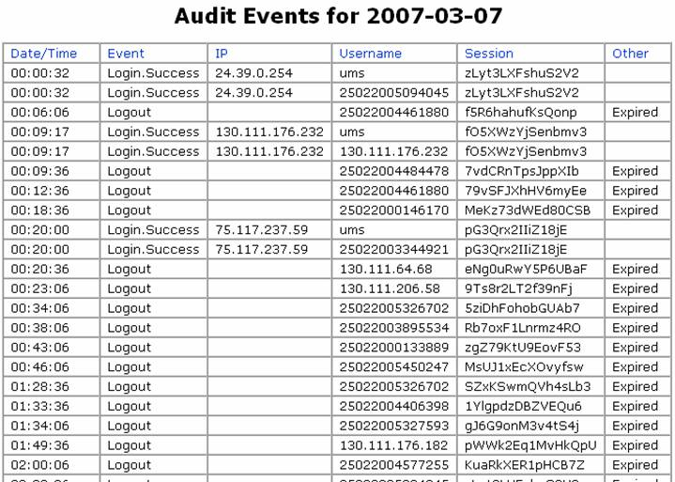

Figure 2.
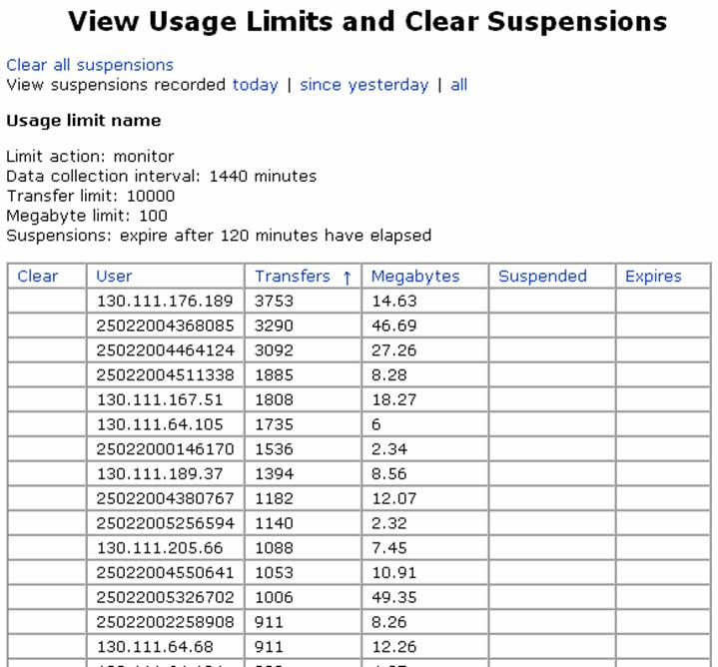

Figure 3
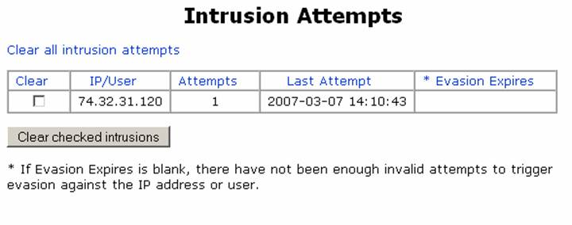
Figure 4

